List of Amendments/Additions
Approved at the General Meeting on 17-Aug-2003

Note: Words in bold font and stroked through such as Paid Secretary are to be deleted.
Words in bold font and underscored such as Classes of Membership are to be added.
Words in bold font only are explanations and comments.

I. Many eligible members enquire about life membership, as they want to join the Association without having to worry about not paying annual subscriptions on time. This clause is added to include Life Members.

4A. Classes of Membership
There shall be the following four classes of members:
(a) Ordinary Members: Ordinary members are required to pay annual subscriptions and other fees as stipulated.
(b) Life Members: Life members are exempted from paying annual subscriptions and other fees as stipulated. The terms and conditions to join as Life Members shall be decided by the Committee.
(c) Associate Members: All clansmen who are Singapore permanent residents may apply to be Associate Members. Associate Members are required to pay annual subscriptions and other fees as stipulated.
(d) Life Associate Members: Life Associate members are exempted from paying annual subscriptions and other fees as stipulated. The terms and conditions to join as Life Associate Members shall be decided by the Committee.
Except specifically stated, the word Member shall include all four classes of Members.

As results of inclusion of Clause 4A, Clauses 4,6 and 26 have to be changed as shown.

4. Entry and Reapplication Procedure:
Eligibility for Membership:
(a) Any person of the Foo Clan clan, irrespective of sex and age, who agrees to the Association's objects and is of good character, will be eligible to be a member. However, any woman, not surnamed Foo, who is not the wife of a member is not eligible for membership.
(b) An applicant must be introduced by a member and shall be required to complete the necessary application form. After his application has been approved by the Committee, the applicant shall be required to pay an entrance fee of S$10.00. Upon approval by the Committee and payment of entrance fee and one year subscription or Life Membership fee, the applicant is then given the status as Member.
(c) Applications from members who had resigned membership and subsequently wish to rejoin the Association shall be considered by the Committee. If their applications are approved, the Committee may, at its discretion, require them to pay all arrears from the day they resigned.
(d) No person other than a citizen of Singapore shall be admitted as a member of the Association. The Association shall not alter this rule without first obtaining clearance in writing from the Controller of Residential Property.
(e) All clansmen who are Singapore permanent residents may apply to be associate members.

6. Obligations
Members shall be required to fulfil the following obligations:
(a) To abide by the rules and resolutions of the Association.
(b) Ordinary Members and Associate Members are to pay the Spring and Autumn Sacrificial Ancestral Worship fees and other fees in accordance with the Association's rules and resolutions.
(c) To recruit new members for the Association.
(d) To help in the running of the Association's affairs.
(e) To help fellow members.

26. Spring and Autumn Sacrificial Ancestral Worship Fees:
(a) Sacrificial Ancestral Worship fees for the Spring and Autumn Sacrifices Ceremonies shall be stipulated by the Committee having regard to prevailing commodity prices.
(b) All new members except Life Members shall pay an entrance fee of S$l0.00.
(c) Every Ordinary Member and Associate Members shall contribute twice a year, i.e. on the Spring and Autumn Sacrificial Ancestral Worship Days, S$2.00 each towards a fund for the purpose of awarding prizes to members' children for their scholastic achievements.

II. This clause is changed to reflect the latest format for constitution where details are left out. The Committee will then be able to adjust to the situations without binding by the constitution.

5. Privileges:
Members are entitled to the following privileges in accordance with the Association's rules:
(a) They can elect, and are eligible for election as Committee Members. (*Age 18 years and above)
Members are entitled to the following privileges subjected to the rules and regulations of the Association:
(a) Any Ordinary Member or Life Member who is 18 years old and above can elect, and are eligible for election as Committee Members.
(b) They can make proposals and resolutions at General Meetings of Members.
(c) They can make use of the Association's premises for celebrations.
(d) Members who had no relatives and no means of support may seek financial aid from the Association in case of illness. The Committee, however, shall first verify the facts of the case before arriving at a decision.
(e) Any member who has grievance or is involved in any trouble can apply to the Association for help or mediation, subject to the approval of the Committee.
(f) Every member shall at the time of his demise enjoy the privilege of having the personal condolences and attendance at the memorial service by members of the Association. However, female members shall not enjoy the privilege of having personal condolences and attendance at the memorial service by members of the Association if they get married after becoming members. The wife of any clansman who is divorced or remarried shall be considered as having voluntarily resigned her membership and shall lose all the privileges accorded to the member.
(g) Associate Members and Life Associate Members:
(i) cannot elect and are not eligible for election as Committee Members;
- can make speeches have rights to make presentation but not partake in resolutions at the General Meetings of Members; and shall enjoy other privileges in the same manner as members of the Association.

III. The organization chart is redrawn to better reflect the structure.
General Meeting of Members
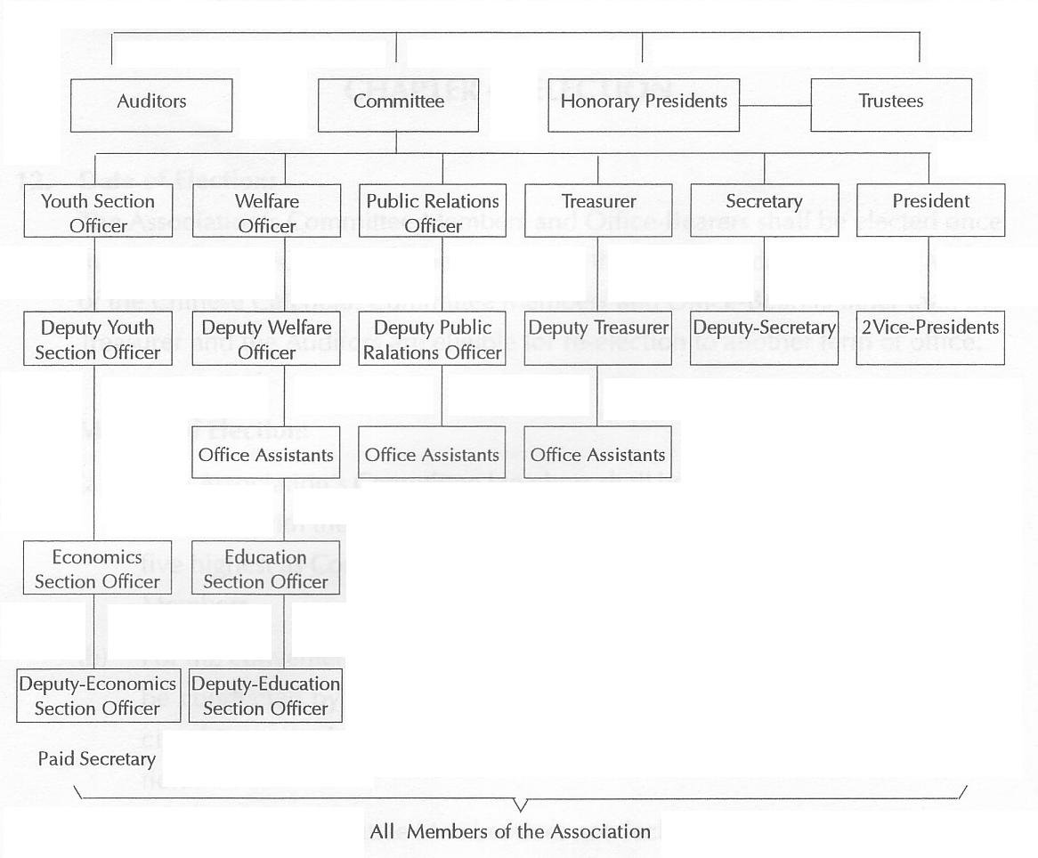
Current chart to be deleted.
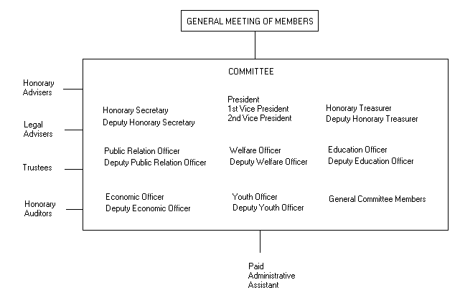
Proposed chart.
IV.Some young Members or professionals may be keen to serve the Committee but may not be elected. The change is to allow Committee to co-opt up to three Members to join the Committee.

8. Committee
The Committee shall consist of 35 Committee Members to be elected at the General Meeting of Members. In addition, 5 Reserve Committee Members shall be elected. The Committee so formed may co-opt up to three Members to be Committee Members. At the close of the General Meeting of Members, the Committee shall be the supreme executive body.

V. In case when the number of elected members falls short of 35, the Committee shall be given the power to co-opt Members into the Committee without having to hold another election.

13. Method of Election:
- The Association's Committee Members shall be elected by members. Forty members with the highest number of votes shall be elected - the first thirty five highest as Committee Members and the last five as Reserve Committee Members. In the event of shortage of elected members, the Committee Members elected may co-opt Members as Committee Members to make up the number.

VI. This clause is changed to reflect that there is only one Annual General Meeting and gives flexibility to the Committee to hold the meeting on a suitable day. Additional details for the conduct of AGM are also added. The number of Members to form a quorum is reduced to 45 to reflect the reduced effective number of members. Other meetings may be held at the discretion of the Committee. The number and days for Ancertral Worship Ceremonies, remain fixed.

14. Dates:
- There shall be two General Meetings of Members - the first on Spring Sacrificial Ancestral Worship Day, i.e. the first Sunday after the 15th day of the First Month of the Chinese Calendar and the second on the Autumn Sacrificial Ancestral Worship Day, i.e. the first Sunday after the 15th day of the Seventh Month in of the Chinese Calendar.

The presence of 45 members shall form a quorum for a General Meeting of Members. In the event of there being no quorum, the Meeting shall be adjourned for half an hour and should the number then present be insufficient to form a quorum, those present shall be considered a quorum, but they shall have no power to amend the Constitution.

Any Ordinary Member or Life Member who wishes to place an item on the agenda of a General Meeting may do so provided he gives written notice to the Honorary Secretary three weeks before the Meeting is due to be held.

15. Number of Meetings and Quorum:
(a) There shall be a Meeting of Committee Members once in every two months. In case of emergency or on the requisition of five Committee Members in writing, the President shall call such a meeting.
(b) The presence of 60 members shall form a quorum for a General Meeting of Members while Attendance of one-third of the total number of Committee Members shall form a quorum for a Meeting of Committee Members. If a Committee Member is unable to attend a meeting on account of urgent affairs, he shall give notice in writing to the Association. In the absence of a quorum in two successive abortive meetings, then those present at the third meeting, whatever their number, shall form a quorum and all the resolutions passed shall be effective.
- Any Committee Member who, without giving prior notice in writing, has absented himself from three successive Committee Meetings shall be considered as having vacated his office and his the vacancy shall be filled by a Reserve Committee Member.

VII. These are additional clauses added to complete the description of duties and powers of all subcommittees. Clauses 21 and 23 are also changed to suit the prevailing conditions.

21. Duties of Powers of paid Secretary Paid Administrative Assistant:
(a) Overall In charge of the Association's correspondence, accounts, etc. and helping in the affairs of the various Sections.
(b) To draft the agenda for the General Meetings of Members and Committee Members and to distribute notices under the direction of the President.
(c) To record the minutes of the General Meetings of Members and Committee Meetings.
(d) To put up resolutions and documents on the notice board under the direction of the President.
(d) To carry out duties as directed by the President or the Honorary Secretary.

23. Duties and Powers of the Welfare Officer:
(a) Overall in charge of relief and welfare matters of members.
(b) To assist members to obtain employment.
(c) To handle all matters regarding awards in accordance with the resolutions of the Committee.
(d) To compile reports on the Welfare Section's work in conjunction with the Paid Secretary Administrative Assistant.
[
23A. Duties and Powers of the Economic Section Officer:
(a) Overall in charge of the economic affairs of the Association.
(b) To assist in long term planning of the Association.
(c) To conduct talks and seminars of interest to members.

23B. Duties and Powers of the Education Officer:
(a) Overall in charge of scholarship matters.
(b) To provide educational talks on the history of Foo clan.
23C. Duties and Powers of the Youth Officer:
(a) Overall in charge of matters relating to the young members and children of members.
(b) To organize meaningful activities for the young members and children of members.

VIII. This clause is added to provide guidelines to Members on decision regarding request for donations by external organizations.

29A. Donation to Other Organisations
Members shall not commit to donate to other organizations at the expenses of the Association without the approval of the Committee. Any donation to other organizations must be approved by the Committee and recorded in the minutes of meeting before payment shall be made.

IX. This clause is modified, as Mahjong game is no longer prohibited according to the new guidelines of the Registry of Society.

37(a) Gambling of any kind such as the playing of paikow or mahjong, whether for stakes or not is forbidden on the Association's premises. The introduction of materials for gambling or opium smoking and of bad characters into the premises is prohibited.

X. The terms that are changed are presented in the following table.
.
OLD TERMS | NEW TERMS
Sacrificial Day | Ancestral Worship Day
Sacrifices | Ceremonies
Secretary | Honorary Secretary
Treasurer | Honorary Treasurer
Paid Secretary | Paid Administrative Assistant
Right to make speeches | Right to make presentation
Power of | Duties and Power of

XI. This clause is modified to be consistent with the clause in the Mandarin version.
12. Date of Election:
The Association's Committee Members and Office-Bearers shall be elected once in every two years, during the period from 11th to the 20th day of the First Month of the Chinese Calendar. Committee Members and Office-Bearers other than the Treasurer and the Auditors are eligible for re-election. to another term of office.

Note: The numbering of the clauses has to be adjusted if the amendments carry.

END OF LIST

